POLAR COORDINATES

- Plot each of the following points on the polar coordinate plane. Be sure to label each point!
Solution
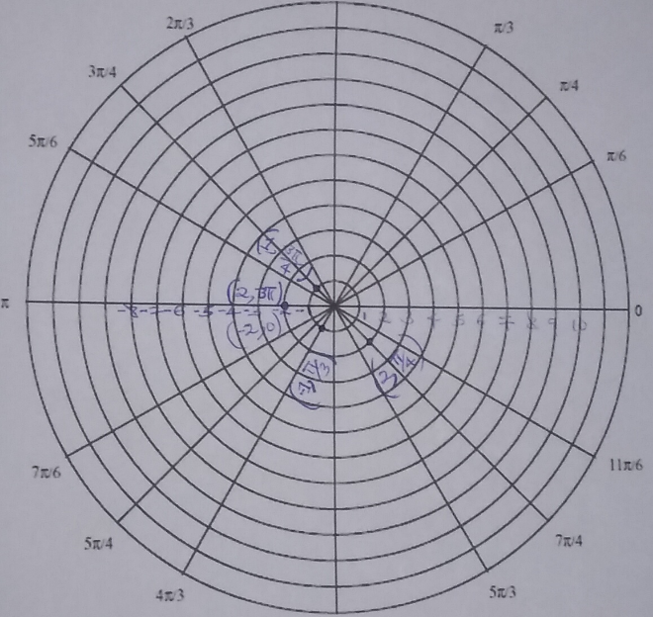
2) Convert the following polar coordinates to cartesian/rectangular coordinates.

Solution
$x=rcos(θ)$
$x=4cos(\frac{π}{6})$
$x=3.4641$
$y=rsin(θ)$
$y=4sin(\frac{π}{6})$
$y=2$
Hence,
Rectangular coordinates are $(3.4641,2)$

Solution
$x=rcos(θ)$
$x=-2cos(\frac{π}{3})$
$x=-1$
$y=rsin(θ)$
$y=-2sin(\frac{π}{3})$
$y=-1.7321$
Hence,
Rectangular coordinates are $(-1,-1.7321)$

Solution
$x=rcos(θ)$
$x=1cos(\frac{3π}{2})$
$x=0$
$y=rsin(θ)$
$y=1sin(\frac{3π}{2})$
$y=-1$
Hence,
Rectangular coordinates are $(0,1)$

3) Convert the following cartesian/rectangular coordinates to polar coordinates.
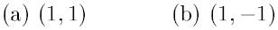

Solution
$r=\sqrt{x^{2}+y^{2}}$
$r=\sqrt{1^{2}+1^{2}}$
$r=\sqrt{2}$
$θ=\tan^{-1}\left(\frac{y}{x}\right)$
$θ=\tan^{-1}\left(\frac{1}{1}\right)$
$θ=\tan^{-1}\left(1\right)$
$θ={45}^{°}$ or $\frac{π}{4}$
Hence,
Polar coordinates are $\left(\sqrt{2}, \frac{π}{4}\right)$
b.
Solution
$r=\sqrt{x^{2}+y^{2}}$
$r=\sqrt{1^{2}+{(-1)}^{2}}$
$r=\sqrt{2}$
$θ=\tan^{-1}\left(\frac{y}{x}\right)$
$θ=\tan^{-1}\left(\frac{-1}{1}\right)$
$θ=\tan^{-1}\left(-1\right)$
$θ={45}^{°}$ or $\frac{π}{4}$ but the angle falls in the second or fourth quadrant, therefore correct angle of $θ=\left(π-\frac{π}{4}=\frac{3π}{4}\right)or \left(2π-\frac{π}{4}=\frac{7π}{4}\right)$
Hence,
Polar coordinates are $\left(\sqrt{2}, \frac{3π}{4}\right)or\left(\sqrt{2}, \frac{7π}{4}\right)$

4) Express each complex number in polar form.
(a) 4 + 3i (b) -5 – 2i

Solution
$z=a+bi$ , $a=4 and b=3$
In polar form, $z=r(\cos{θ+i\sin{θ}) }$
$r=\sqrt{a^{2}+b^{2}}$
$r=\sqrt{4^{2}+3^{2}}$
$r=\sqrt{25}$
$r=5 units$
$θ=\tan^{-1}\left(\frac{b}{a}\right) for a>0 and θ=\tan^{-1}\left(\frac{b}{a}\right)+π for a<0$
In this case, $a>0$ therefore, $θ=\tan^{-1}\left(\frac{3}{4}\right)=0.2048π$
Hence, $z=5[\cos{(0.2048π)+i\sin\left(0.2048π\right)] }$

Solution
$a=-5 and b=-2$
In polar form, $z=r(\cos{θ+i\sin{θ}) }$
$r=\sqrt{{(-5)}^{2}+{(-2)}^{2}}$
$r=\sqrt{29}$ units
$θ=\tan^{-1}\left(\frac{b}{a}\right)+π for a<0$
In this case, $a<0$ therefore, $θ=\tan^{-1}\left(\frac{-2}{-5}\right)=0.1211π+π=1.1211π$
Hence, $z=\sqrt{29}[\cos{(1.1211π)+i\sin\left(1.1211π\right)] }$

5) Express 5 cis 320⁰ in rectangular form.

Solution
$5(\cos{{320}^{°}+i\sin{{320}^{°}) }}$
$5(\cos{{320}^{°}+i\sin{{320}^{°})=5(0.7660+i\left(-0.6428\right)=3.83-i3.214 }}$
Hence,
5 cis 320⁰ in rectangular form is $3.83-i3.214$

